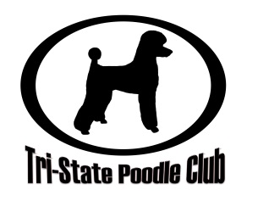

As a member of Tri-State Poodle Club, Inc. I commit to:
- Support the Club mission to promote and protect poodles by participating in at least one of the Club’s four focuses: community, education, performance, and/or rescue.

- Maintain the best possible standard of care for my dogs with regard to nutrition, housing, safety, grooming, exercise, cleanliness and veterinary care.

- Seek to understand and fulfill the specific needs of my poodle(s) including its high need for socialization and great deal of human contact.

- Consider re-homing my poodle if at any time I should no longer have time or resource to fulfill all its needs.

- Seek the advice and insight of more experienced breeders and owners and graciously provide what assistance I can to those wishing the same from me.

- Display good conduct and sportsmanship at all times, respecting both the wins and the losses of others in competition, whether at home, traveling, or at shows.

- Refrain from serious obedience, agility or other physically demanding training until a puppy is of a suitable age where it has both the strength of body and mental capacity to endure such demands.

- Ensure tagged collars are worn when my dogs are away from home and it is safe and permitted to do so.

- Responsibly clean up after their dogs in public places.

- Contact the club should I need help re-homing a dog.

- Sign the TSPC breeder code of ethics before breeding my dogs.

- Conduct any business dealings concerning my or others’ dogs in an ethical manner.

- Abide by the by-laws set by the Club.

- Act in the best interests of the breed, the Club, and the membership as a whole, in all questions of ethics covered or not covered by this Code.

- Bear in mind that a Code of Ethics is more than a set of rules, understanding that it is a commitment to a high standard of practice in owning and breeding and that adherence to the spirit of the Code is as important as adherence to its law.
I understand that any breach of the Code of Ethics brought to the Board's attention will be responded to with the primary intent of correction, education, and restoration but, when appropriate, may include expulsion from Club membership and/or reporting to the relevant authorities.

Name:________________________________________ Date:________________________________________

Signature:___________________________________________________________________________________

